**CONTACT US**

Contact us page needs to be similar to Veezu

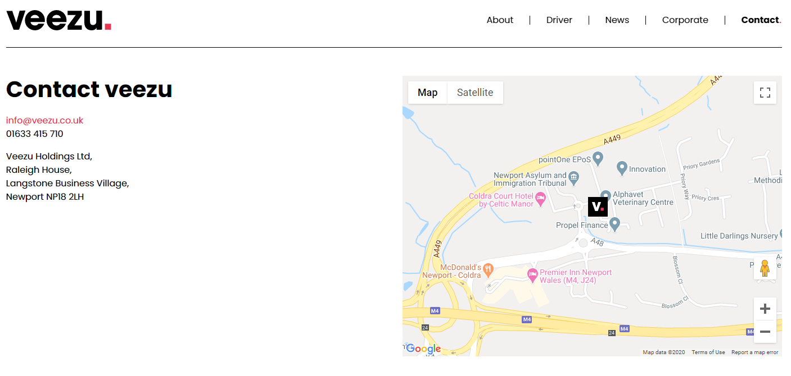

However, we need to have it similar to…

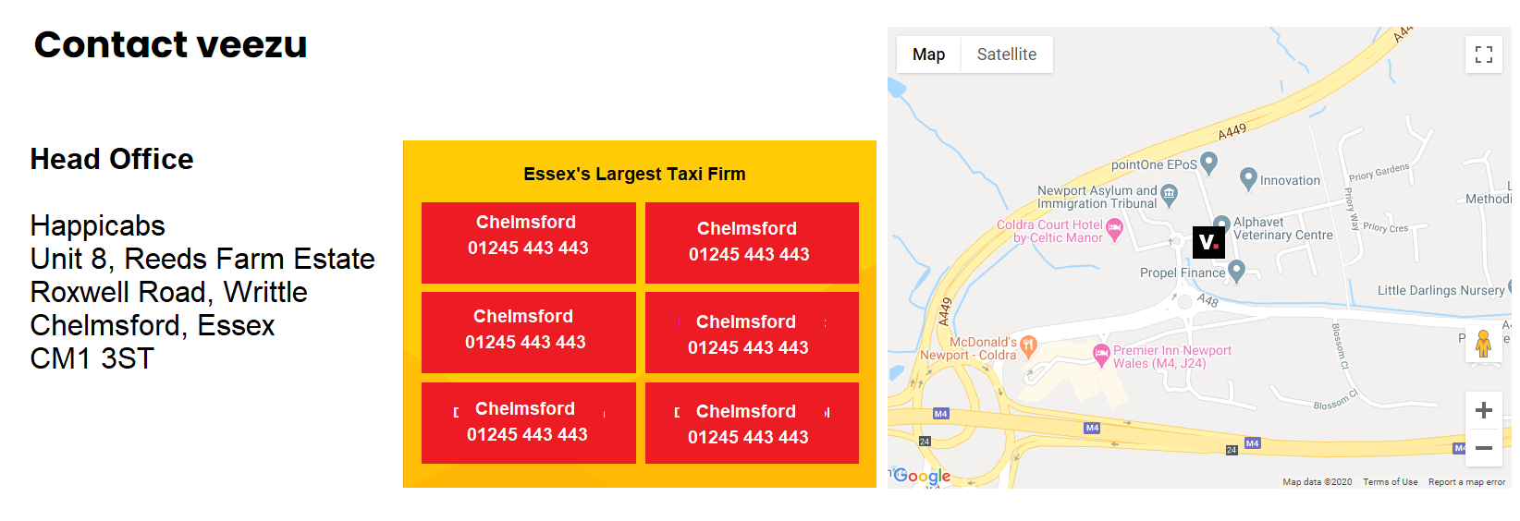

We need a section that shows our head office with the map including different contact numbers for each branch. However, our Head Office Address must be the main and only address displayed. Under branches, we may also include email addresses should customers need to reach us.

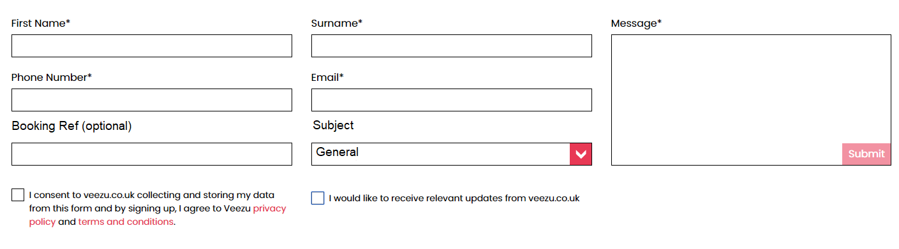

The form needs to be similar to above. The subject drop-down should give options for: General Enquiries, Accounts, Recruitment, Complaints, Feedback, Lost Property, Receipt Request

If we can incorporate a MailChimp mailing list to get customers registered to our marketing email database that’ll be great. I am unsure how you would link the two together in one generic form that has a purpose to deliver messages to our control room.